These Perilous Times
Vol. 17, Dec. 21, 2025

“Yes, We Have Many Gifts to Bring”

This time of year, there are many songs and hymns being sung and played on instruments to personify the birth of our LORD and REDEEMER-KING JESUS! Many families during this holiday season are spending their time and money, “Christmas Shopping” stressing-out while trying to select the right gift/gifts for their loved ones and friends. Is it wrong to give good gifts to family and friends? Absolutely not (See Matt. 7:11). Is it wrong to worry and be stressed in the process, absolutely (See Matt. 6:34). There is one song that is aired over the radio waves this time of year that perhaps gets us thinking-about what gifts we have, to bring for KING EMMANUEL? Notice one of the verses of, “The Little Drummer Boy.”
“…Baby Jesu, pa rum pum pum pum… I am a poor boy too, pa rum pum pum pum.
I have no gift to bring, pa rum pum pum pum… That’s fit to give the King,
pa rum pum pum pum, rum pum pum pum, rum pum pum pum.
Shall I play for you, pa rum pum pum pum, on my drum?

What does this mean for us?

Obvious Signs Do Tell The Season

This holiday season let us do our best as God’s “Remnant People” to use our time, money, talents, and gifts for winning souls! Unlike the “Little Drummer Boy,” Our church collectively has a host of gifts for our KING to help win others to Him, through the spreading of the Gospel (See I Cor. 12:4-11; Eph. 4:8, 11-14, 28-31). Everyone who surrenders their life to our LORD and SAVIOR and is baptized has at least one gift to be used for our KING! If we do not use our gifts and talents for our LORD, we will lose them! (See the parable of the talents-Matt. 25:14-29). So, let us all work together this holiday season to hasten our LORD’S return by spreading the Good News of the gospel!

“And this Gospel of the Kingdom shall be preached in all the world for a witness unto all nations; and then shall the end come.” Matt. 24:14

“The solemn, sacred message of warning must be proclaimed in the most difficult fields and in the most sinful cities, in every place where the light of the great threefold gospel message has not yet dawned. Everyone is to hear the last call to the marriage supper of the LAMB.
From town to town, from city to city, from country to country, the message of present truth is to be proclaimed, not with outward display, but with the power of the SPIRIT.”

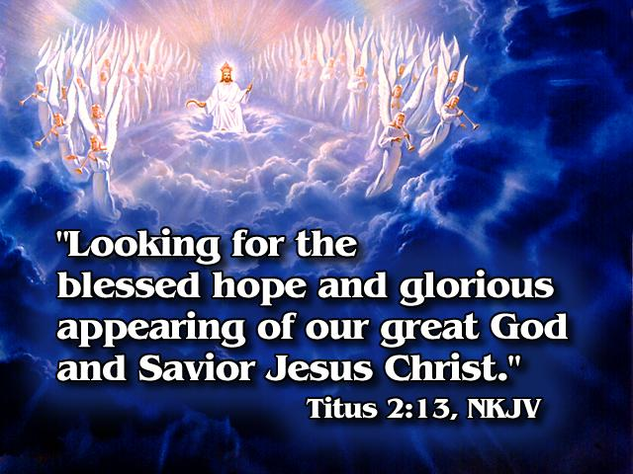


E. G. White. Gospel Workers, p. 27.

