These Perilous Times
Vol. 13, No. 19 Oct. 7, 2021

“Top Secret”

During World War II, my dad served under General Patton during the “D-Day” invasion and assault on “Normandy Beach Head,” in France. As a result of a serious wound, he received by enemy mortar fire, he lost the lower part his left leg below the knee. After the war he began working for the Department of Civil Defense as a “Readiness Inspector” for the First Army Headquarters District, (Bangor Maine to Fort Knox, Kentucky).
Working with anti-aircraft artillery, and guided- missile systems he was required to have a top secret, security clearance. His job, (as a “readiness inspector”) required him to travel (with his team) to all the military bases in the 1st Army District to see if they were militarily ready to engage in warfare if necessary. If not, they were given precise instructions by the readiness inspector’s team how to prepare.
Most everyone that I know, has had or has at least one secret that they promised they would never reveal, and many have kept their oath. But there are many others who can’t wait to tell someone else what they have heard! Which is a good thing, when it pertains to the Word of God!

What does this mean for us?

Obvious Signs Go Tell The Season

Counsel from God’s inspired messenger
“God calls upon all who minister in the Word and doctrine to give the trumpet a certain sound. All who have received Christ, ministers and lay members, are to rise and shine; for great peril is right upon us. Satan is stirring up the powers of the earth.
Everything in this world is in confusion. God calls upon His people to hold aloft the banner bearing the message of the third angel…”
God’s people are not worldly, existential-philosophical thinkers! We do believe in the Creator, God. We do have a meaningful purpose to fulfil on this planet! We are more than conventional, war-time readiness inspectors! We are “spiritual” readiness preparers! We are involved in the war of wars! The Great Controversy! The battle over worship! The war between good and evil! It’s high time to tell the world about it! It’s time to prepare a people for the Lord’s return! Do not hide your spiritual light (Matt. 5:14-16) under a basket-Let it shine!
The “Three Angel’s” messages (Rev. 14:6-14) are not to be God’s best kept secrets! You have heard it many times before, and now you are hearing it again!

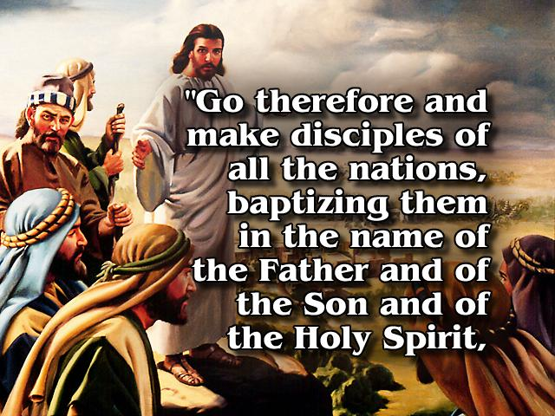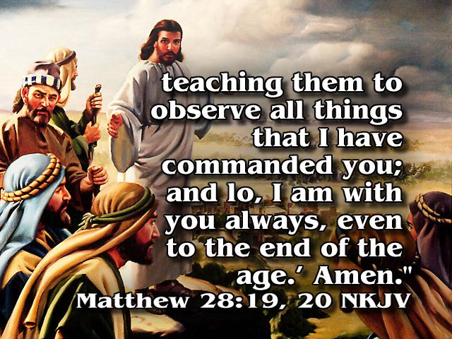

“Therefore, be ye also ready: for in such an hour as ye think not the Son of man cometh.”
Matthew 24:44 KJV

“Permission to Speak-Granted!



E. G. White. Gospel Workers, p. 395.

