These Perilous Times
Vol. 14, No. 5, March, 7, 2022

“ALL Who Will”

The word all means: The whole extent or quantity… the entire number of; every one of…”

“Yea, and all that will live godly in Christ Jesus shall suffer persecution.” II Tim. 3:12 (Italics supplied) KJV

What does this mean for us?

Obvious Signs Do Tell The Season

“…Now as in former ages, the presentation of a truth that reproves the sins and errors of the times will excite opposition. ‘Everyone that doeth evil hateth the light, neither cometh to the light, lest his deeds should be reproved,’ (John 3:20 KJV).
As men see that they cannot maintain their position by the Scriptures, many determine to maintain it at all hazards, and with a malicious spirit they assail the character and motives of those who stand in defense of unpopular truth. It is the same policy which has been pursued in all ages. Elijah was declared to be a troubler in Israel, Jeremiah a traitor, Paul a polluter of the temple. From that day to this, those who would be loyal to truth have been denounced as seditious, heretical, or schismatic.” (See also John 15:18-20).

Are you ready for the whirlwind?

We know the day is soon approaching when Papal Rome, the Little Horn/Anti-Christ beast power of Dan. 7:8; 8:9-12; Rev. 13:1-10, and the United States, the Lamb-like beast power, who will speak like a dragon, Rev. 13:11, will form an unholy alliance, reuniting Church and State once again.
“In view of this, what is the duty of the messenger of truth? Shall he conclude that the truth ought not to be presented, since often its only effect is to arose men to evade or resists its claims? No; he has no more reason for withholding the testimony of God’s word, because it excites opposition, than had earlier reformers…”

Counsel from Timothy

“… Preach the word! Be ready in season and out of season. Convince, rebuke, exhort, with all longsuffering and teaching. For the time will come when they will not endure sound doctrine…they will turn their ears away from the truth, and will be turned aside to fables.” II Timothy 4:2-4 NKJV

“… and all the world wondered after the beast.”
Rev. 13:3 KJV

A picture is worth a thousand words

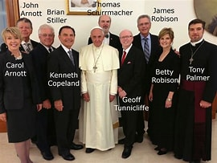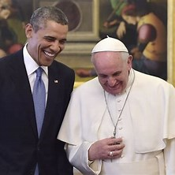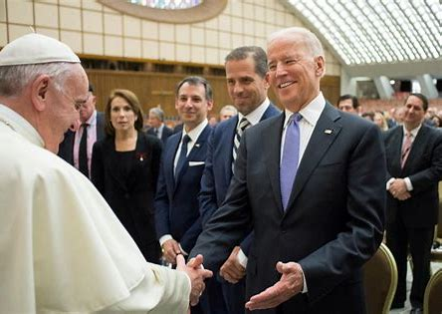
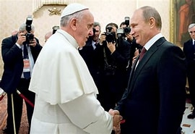

Get the big picture?

Websters New World Dictionary, (College ed.), Cleveland & New York, The World Publishing CO., 1964, p. 38.
E. G. White. TheNew Illustrated Great Controversy, Deland, FL., Layman For Religious Liberty Inc., 1990, pp. 458, 459.
Ibid., p. 459.

